
Malcolm G Boswell, Workforce Analyst * P.O. Box 2070 Gresham OR 97030 * (503) 666-1985 Ext. 309 * Malcolm.G.Boswell@state.or.us

Columbia Corridor
Industry Employment and Wages

This data is based on the annual averages of the Quarterly Census of Employment and Wages (QCEW) for 2000 through 2003. Annual data for 2004 is not included since fourth-quarter information is still being compiled and processed. QCEW data is based on employment and wage information provided by businesses for unemployment insurance tax collection. These data are reported quarterly, with three months for reporting, and another three months for review and adjustments. Thus QCEW data are published about six months after the end of each quarter. More than 90 percent of all Oregon companies are subject to reporting employment and wages, so statewide data has a high confidence level. Even so, statewide data are still subject – to a lesser degree – to the same caveats to which regional, county and sub-county aggregations are subject. These caveats tend to lower the confidence level the smaller the geographic breakout. Some factors that lower the confidence level of data include centralized reporting, use of third party accounting and payroll services, administrative changes, and confidentiality regulations.

- Centralized reporting affects data since companies with multiple locations or branches report employment and wages for all sites under one address. This significantly increases the count for employment and wage data in the area where the reporting unit is located, and undercounts it in areas where their branches are located. The Oregon Employment Department has worked with many of these companies to get data by place of employment, which increases data reliability at the various geographic levels.

- Third-party accounting and payroll services can have the same impact as centralized reporting. In many cases, the reporting address provided is the payroll service company’s address and not the actual business address of the company it represents. That accounting or payroll service company may or may not be in the same area as the company where the work is performed. When this is the case, analysts see an undercount in one area and an overcount in the other. OED is working with these companies to improve the reporting of the actual location where the work is performed.

- The most common administrative change has to do with the assignment of an industry code based on a company’s primary activity. When a company changes its industry classification or code, it causes a shift of employment and wage data from one industry to another. This creates artificial job gains and losses in individual industry segments, but do not change the all-industries totals. The reasons for individual companies to reclassify industry designation can be traced to changes in business focus, ownership, and technology. Another, less common, administrative change is changes or updates in the industry classification system itself. In 2001, there was a significant reclassification of industries due to a change of industry classification coding systems from Standard Industrial Classification Manual (SIC) to the North American Industry Classification Systems (NAICS). This reclassification caused series breaks for historical trend analysis. It generated new major industry groups, including management of businesses and enterprises (NAICS 55) and information (NAICS 51), and allowed for the introduction of new industry codes for emerging or restructured industries.

Confidentiality of data is guided by federal and state rules that govern the use and distribution of information gathered from businesses from federal or state surveys or the unemployment insurance reporting process. Basically, the Oregon Employment Department cannot provide data for any industry or industry group where there are less than three businesses or if any one business employs 80 percent or more of the workers in that industry or industry group. When an industry segment or group becomes confidential, one of two things happens: a) the data is replaced with a code indicating the data is not available and is then not included in the total for all industries or b) it is rolled up to the next higher level of aggregations (from a four digit NAICS aggregation to a three or two NAICS code level aggregation) so the breakout is not visible but the data is included in the total for all industries.

One general caveat that applies to all situations is that the level of detail that can be provided decreases along with the geographic area for which data are provided.

It is important to understand the data’s dynamic nature, because it helps explain changes in the distribution and aggregation of the industry data used in economic analysis. It also helps explain significant changes in employment and wage data for a specific industry group from one year to the next that is not reflected in the total employment and wage data for all industries in that area. Most changes, however, are real changes, and the sum of positive and negative changes of each industry group can result in minimal change in the total for all industries.

Geo-coding data brings an additional set of caveats that must be noted. Geographic Information Systems (GIS) allow us to total data based on nontraditional geographic boundaries not based on such common boundaries as zip codes, city limits, county limits and census tracts. However, these nontraditional geographic breakouts are usually associated with new development areas that include addresses not yet plotted in GIS mapping tools. When the exact street address of a business is not found, it is plotted in the center of the reported zip code, which may not be inside the unique boundary that is being studied. This can cause an undercount in the industry group and the total for all industries for that area. An overcount can occur if a company whose physical address is outside the boundary, but not found on the mapping system and plotted to the center of the reported zip code inside the boundaries of the study.

The Columbia Corridor data are based on a boundary provided in 1999, and it includes businesses on both sides of the streets that make up the boundary. Before implementing GIS, employment and wage data in the Columbia Corridor was totaled based on the sum of all businesses in the zip codes where more than 50 percent of the zip code fell within the corridor’s boundary. This created an overcount that, given the capabilities of the time, was acceptable for planning purposes. Comparisons between this and previous reports of industry employment and wages are not recommended, as the methodology used was different and, thus, the results were different. Geo-coding provides a more accurate – though not perfect – picture of economic activity in the Columbia Corridor.

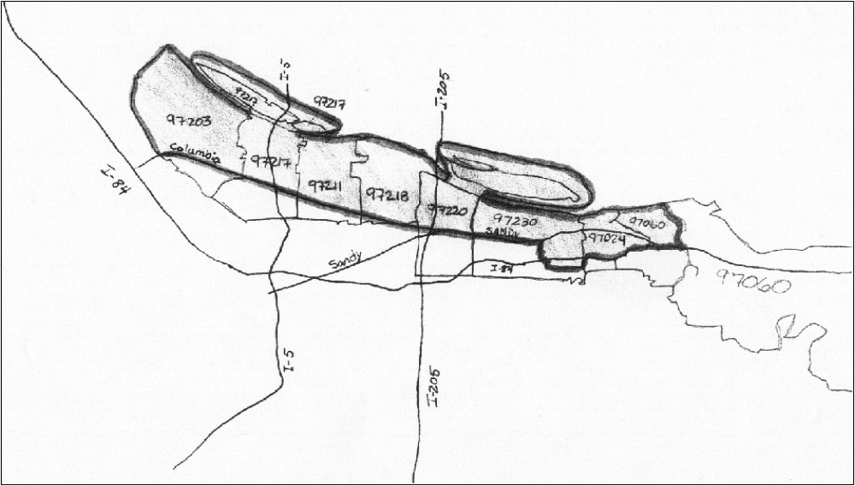
Figure 1 - Map of Columbia Corridor boundaries and related zip codes.

Industries

The Columbia Corridor’s industry mix reflects its proximity to the Columbia River and all the transportation infrastructures associated with it. The corridor has three major interstate arteries, two airports, a maritime port that ranks third in the Northwest in total commerce volume, and access to two major railroad systems. In 2003 (latest complete year for which industry data is available) there were 2541 businesses in the corridor, accounting for an average of 60,150 jobs during that same year.

Three of the top four industry groups are related to manufacturing and distribution and warehousing of goods (Graph 1). The fourth is a diverse service industry that supports the business needs of the first three. The largest service industry segment in the Columbia Corridor is the lodging and food services segment, followed by a mix of business and personal services.

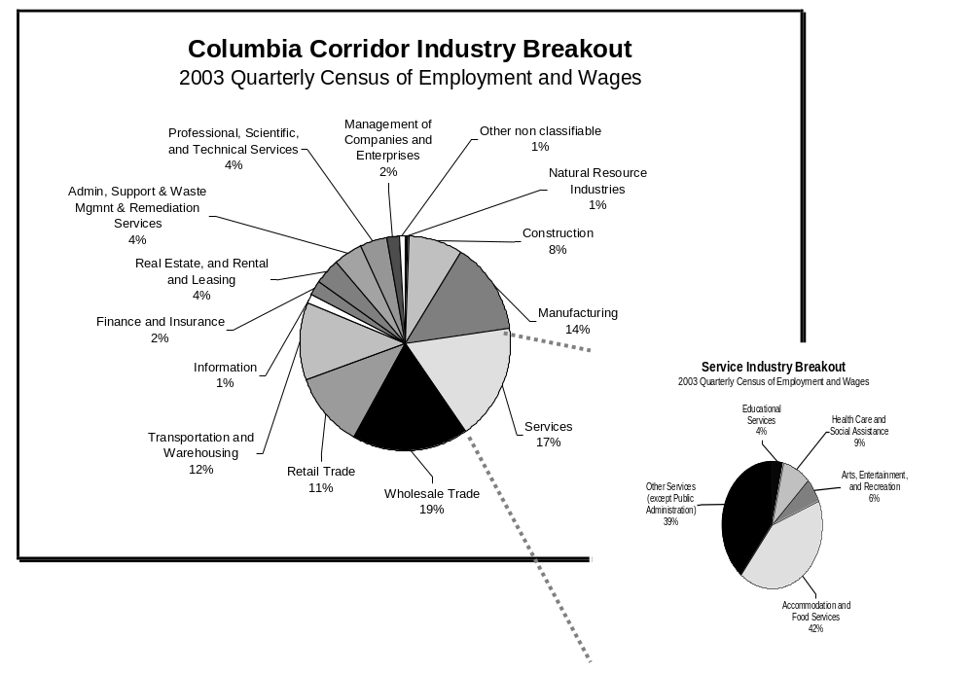
Graph 1

The Columbia Corridor saw minimal changes in the number of businesses from 2000 through 2003 (Graph 2). This indicates resilience to an economic downturn during that time, which affected most of the Portland metropolitan area. However, this resilience did not prevent job losses (graph 3). Almost all industry segments lost jobs, but none as much as the manufacturing segment, which lost just over 3,600 jobs in that period. Retail saw the second-largest number of losses, with 1,837 jobs shed. However, these segments added employment during that time: the administration, support and waste management industries (+699); finance and insurance (+636); and the information industry (+ 198).

In terms of employment distribution by industry segment, Graph 4 provides a quick glance of the mix in 2003. Despite having the largest decline in workers over a four-year period, the manufacturing industry in Columbia Corridor still provides the most employment. One out of every four people who work here is employed in this industry sector.
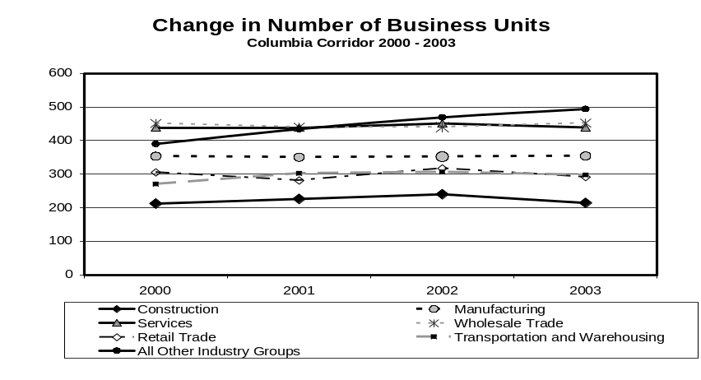
Graphic 2

Warehouse and transportation followed with a 20-percent share. The service and wholesale segments added 16 percent and 12 percent, respectively, of the jobs, for a total of 73 percent of all jobs in these four industries. Again, a cross section of the service industry shows that 57 percent of those jobs were in accommodation and food services.
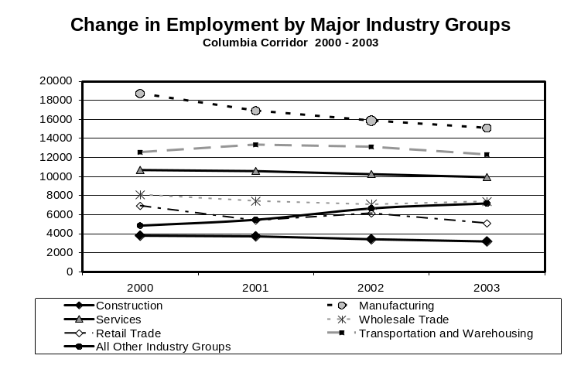
Graph 3

Overall, industries in the Columbia Corridor saw about a 4.1 percent increase in wages.

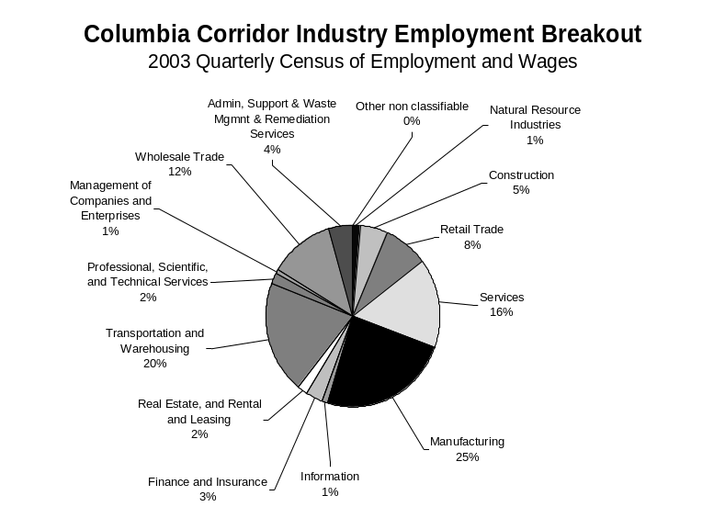
Graph 4

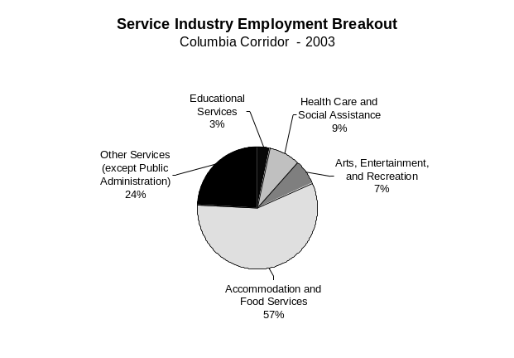

However, the increase in wages was not seen in all industry segments. Table 1 shows the average annual wages from 2000 to 2003 and the percent change between 2003 and 2000 wages.

The finance and insurance segment had the largest overall annual average wage increase with 34 percent. Educational services followed with 21 percent; real estate, 19 percent; arts, entertainment and recreation, 19 percent; professional, scientific and technical services, 18 percent; and other services, except public administration, 14 percent. Whether these increases are real or due to shifts in the proportion of knowledge-based positions to non-knowledge-based positions is not known. A combination of both may be the likely reason. On the other hand, four industry segments saw a decline in average annual wages. Those were: management of companies and enterprises (-9 %), natural resources (-8 %), retail trade (-2 %) and information (-1 %). The dip in management of companies and enterprises jobs may be due to administrative changes in the reporting of wages and employment for this industry segment, which was formed when the North American Industry Classification System replaced the Standard Industry Classification system. It could also be caused by natural market forces that dictate supply and demand. Table 2 offers the same information broken down to hourly average wage by industry.

Table 1
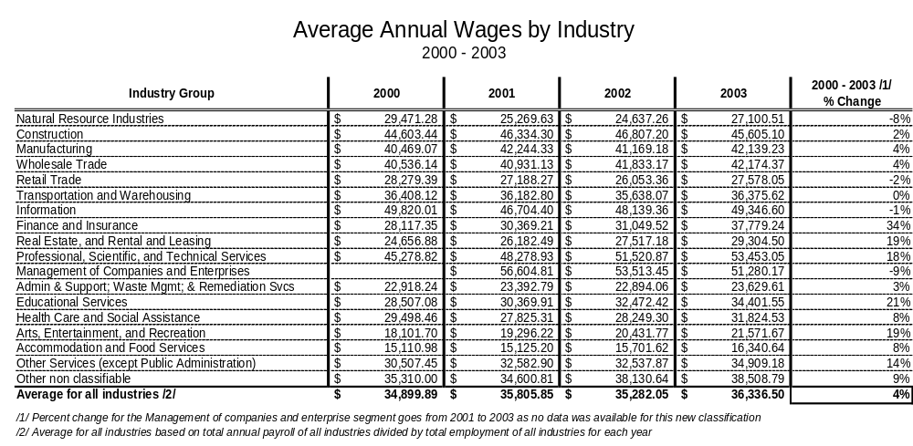
Table 2
